|  |
| --- |
| University of Pretoria |
| Architectural Specification – Stream2Me |
| COS 301 Team Zeon |

|  |
| --- |
| Zenadia Groenewald, Bernhard Muller, Lecton Ramasila  8-22-2014 |

Contents

Change log

|  |  |  |
| --- | --- | --- |
| Date | Version | Description |
| 01/08/2014 | v0.1 | Introduction added |
| 01/08/2014 | v0.1 | System description added |
| 02/08/2014 | v0.2 | Overall architecture added |
| 02/08/2014 | v0.2 | Details of system added |
| 02/08/2014 | v0.3 | System layout diagram |
| 02/08/2014 | v0.3 | Task handling diagram |
| 20/08/2014 | v0.4 | Performance quantified |
| 20/08/2014 | v0.4 | Performance graph added |

1 Introduction

* 1. Purpose

The purpose of this document is to give a high-lever abstraction of the possible architectural strategies and the foundations to be implemented to ensure that the requirements are met as specified in the requirements specification. This document further serves as a preliminary and intermediate specification between high-level requirements and the system’s design.

* 1. Project Scope

The scope of the Stream2Me project is defined as a software solution to enable a user to send, receive and stream media data to one or more other users who are making use of the same application. In its completion, the project will further serve to eliminate the need for actions such as turning a monitor to show someone a video clip, or having to share earphones to listen to audio. This system can be further expanded to business and/or academic environments for collaborative work.

2 System Description

The goal of the Stream2Me project is to provide a data/media streaming service to both desktop and mobile devices to allow for ease of media access and communication within an academic environment. Its primary goal is to eliminate the necessity for the sharing of hardware between persons when attempting to exchange information.

3 Overall Architecture

The chosen architectural frameworks include JSE and Android, as these form part of the desktop and mobile platforms on which the system is to be developed. This system is to be deployed on Android mobile platforms as well as Windows 7 desktop platforms.

The architecture chosen is the MVC (Model-View-Controller) architecture. This specific architecture is chosen because it easily encapsulates the various actions and interactions of the user with the interface; these actions are interpreted and their interaction with the rest of the system is then determined from them and the appropriate response is given. This is all accomplished through the transfer of various different types of messages.

3.1 Architectural patterns

The MVC is the primary architectural foundation that is to be used in the implementation of the Stream2Me project; but in contrast to the typical multi-layer MVC architecture, the project works on only two primary components and three predominant layers, namely the back-end (the server to be hosted on the Internet, which is responsible for the distribution and sending of media and messages to and from various clients; as well as the authentication and security of messages being sent), the security layer (responsible for the encryption of transmitted data as well as ensuring the secure transmission of the data), and the front-end (the client-side interface and the primary interactions with the end-user; where all the actions available to the client are defined). The diagram below illustrates the aforementioned 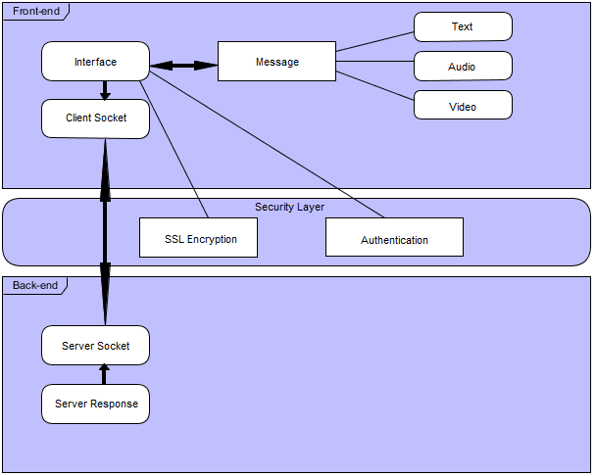architectural structure.

(Figure 1: Architectural Overview)

Front-end

This layer is essentially the adapter to the back-end and is what allows the user to interact with the system on a higher level. This contains the user work flow, ensures the appropriate actions and requests are propagated to the correct parts of the back-end, and renders the result of various actions to the user(s).

* Android client – the mobile application which runs on the Android architecture and provides the interface for the mobile application.
* Windows application – the desktop application and interface through which the user may interact with the system and clients may issue requests to the server.

Security Layer

This layer is responsible for ensuring the security and encryption of transmitted data through encryption on data packets and by enforcing authentication of user information before data may be transferred.

* SSL encryption

Back-end

This layer is responsible for the functionality and actions performed on the server side and is responsible for processing, executing and delivering the results of client requests back to the user at the front-end. These activities are all performed using the TCP protocol as a means of transferring data between the client(s) and the server when an action is performed on the front-end.

* TCP
* Client-server communications.

3.2 Architectural Strategies

Auditability

* User details could be retained with each instance of access in the system.

Constraints

* Open source and available on two different architectures/platforms.
* Audio and video streaming, due to the size of the streamed objects, will cause bottlenecks.
* Currently creates a message arrival delay of up to 40 seconds.

Integrability

* All services are to be implemented first separately and integrated into the system once unit tests are complete.

Maintainability

* Services and system modules will be designed to work both independently and when they are integrated into the system – they will be decoupled in their development.
* Coding standards are to be used in order to make the code flexible and understandable.
* User manuals, help functions and troubleshooting manuals will be included.

Performance

* Threading and priority scheduling to assist in performance enhancement in the events of network traffic or delays.
* Messages, without media streaming, have an average transfer time of about 1 – 2 seconds regardless of the message type.
* Messages, with streaming active, have an average transfer time of between 20 and 70 seconds depending on the size of the streamed object (Video resolution)
* Messages sizes for video averages at about 235.688 KB; audio averages at about 8.04251 KB; and others average between 0.24683 KB and 8.08496 KB.

Reliability

* System must allow for multiple stable client connections simultaneously.
* Reliability to be tested using unit testing.

Scalability

* The framework on both the client and server ends provide resource management (e.g. threading).
* The system must allow for multiple concurrent users (about 400 users maximum).

Security

* Secure and maintainable data transfer protocol (TCP).
* SSL encryption.
* System ensures that data is not interceptable during transmission.
* Local authentication of users (possibly provided by a database).

Usability

* The interfaces of both the mobile and desktop applications should be intuitive to use.
* Must be easy to use through a simplified and minimalistic interface.

4 Details of system

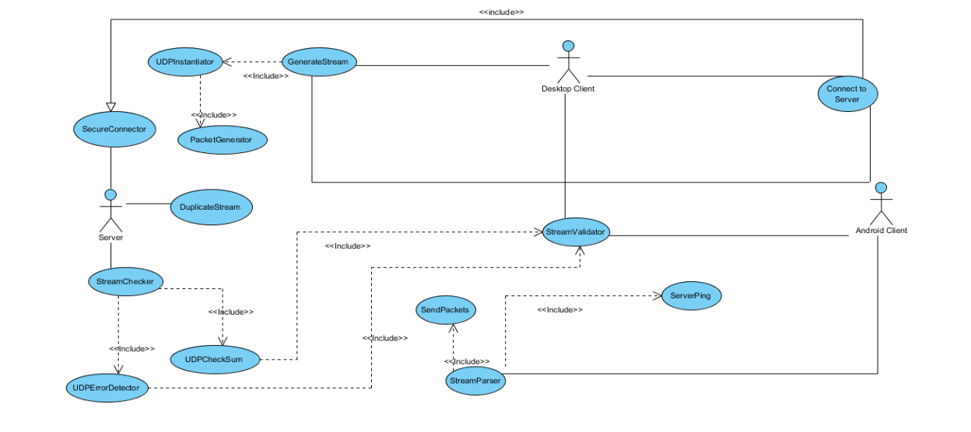4.1 System layout

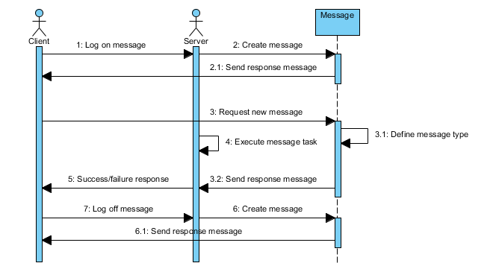4.2 Task handling